|  |  |
| --- | --- |
| **Ex no : 2** | **Collecting Cleaning and Connecting to Data** |
| **Date :** |

**AIM**

To perform data collection and cleaning operations in tableau prep builder.

**PROCEDURE**

Step 1: Download and install the tableau pre-processing builder software 2023.2

Step 2: Run the tableau prep builder, Click on connect to data with text file, as we will connect .csv files as a text file.

Step 3: Go to this path “ C:\Program Files\Tableau\Tableau Prep Builder 2023.2\help\Samples\en_US\Superstore Files\Orders South\orders_south_2015.csv” and connect the file.

Step 4: Similarly, Connect the below two csv for preprocessing

* + - C:\Program Files\Tableau\Tableau Prep Builder 2023.2\help\Samples\en_US\Superstore Files\Orders_Central.csv
    - C:\Program Files\Tableau\Tableau Prep Builder 2023.2\help\Samples\en_US\Superstore Files\Orders_Central.csv

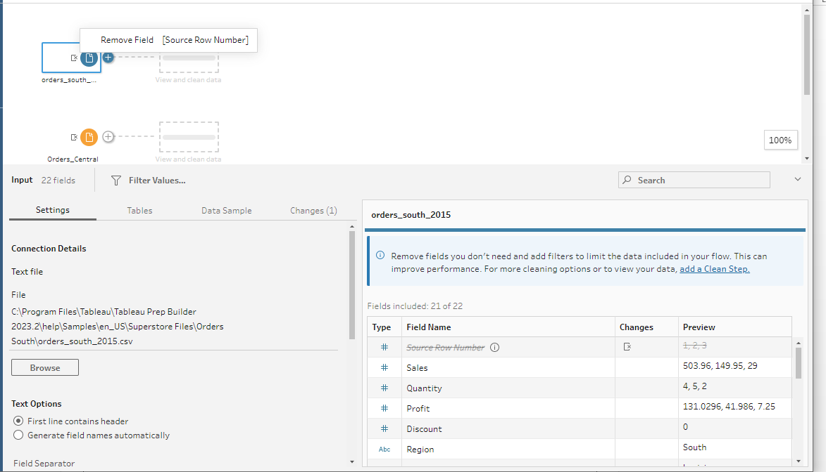

Step 5: Click each file in the flow plane and review all the columns in the input pane of the particular table.

Step 6: You can observe that the Order date and ship date is different in all three tables, so make it same in all the tables.

Step 7: Create a clean step in Orders_South table, then click calculated field,

Choose Field name as: Order Date

And formula as MAKEDATE([Order Year],[Order Month],[Order Day])

Step 8: Do the same for Orders_Central table.

Step 9: Create a union and all the three tables and save it as a tableau file.

Step 10: Open the saved file in tableau desktop

**OUTPUT**

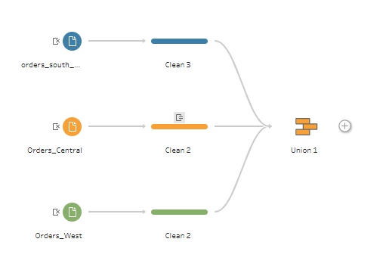

**RESULT**

Thus, To perform data collection and cleaning operations in tableau prep builder has been completed successfully.